**NEXUS ASSIGNMENT**

Creating new project using maven tool and sending the files to nexus

**Steps-1:**

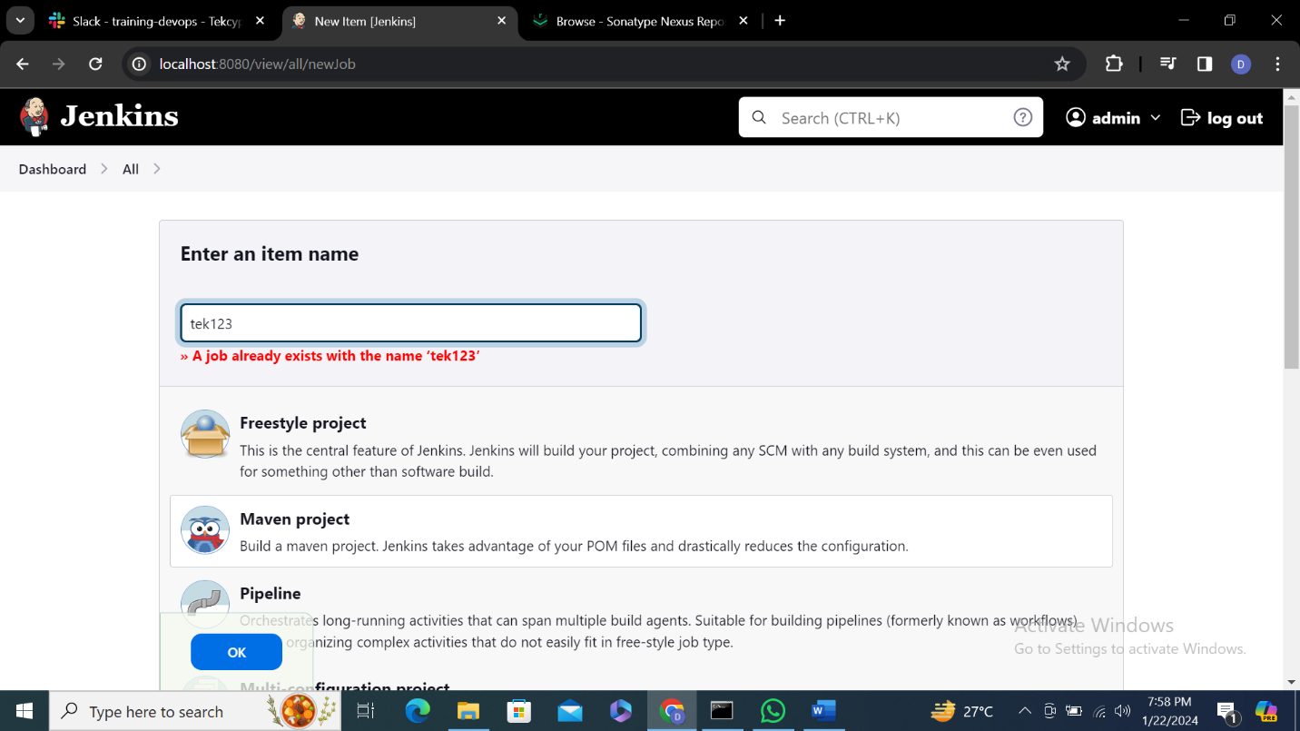

**2.**Give some description

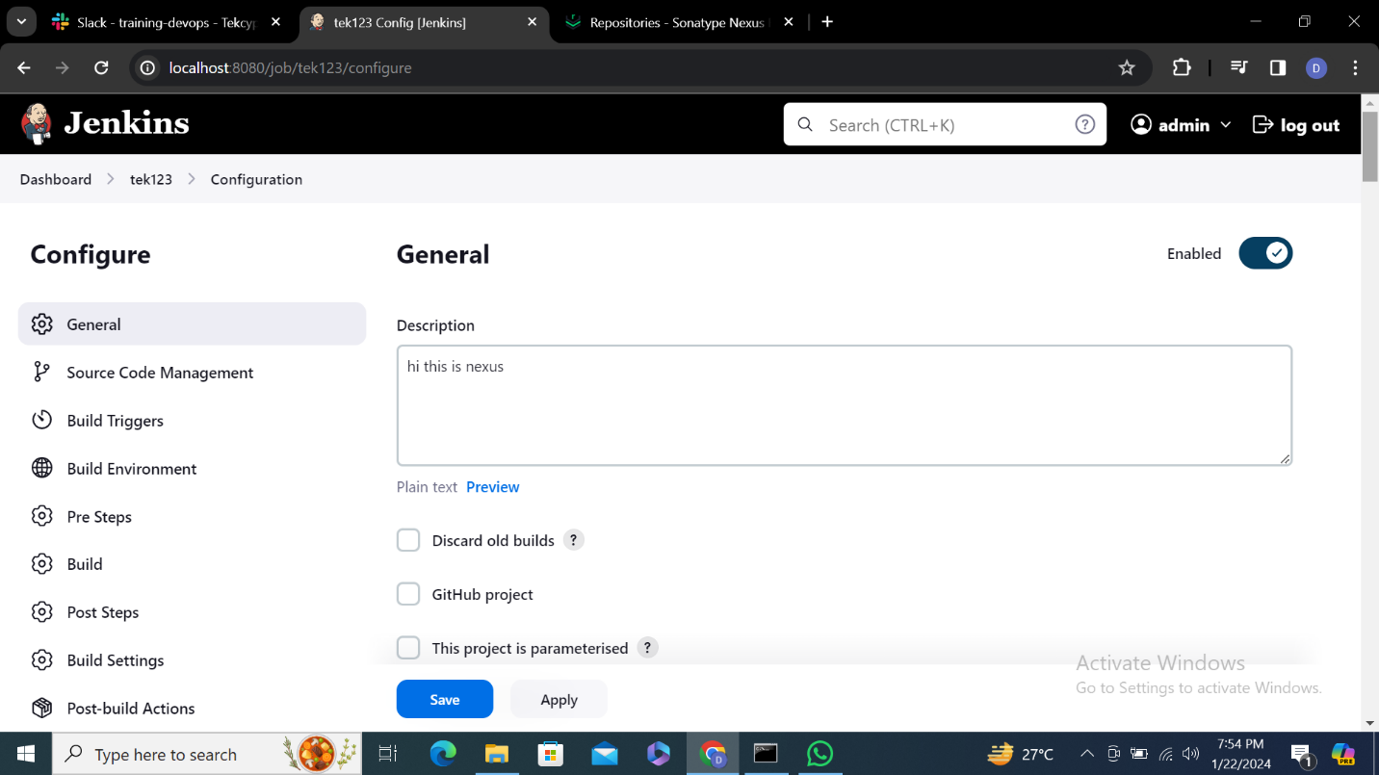

**3.**Enter git hub URL

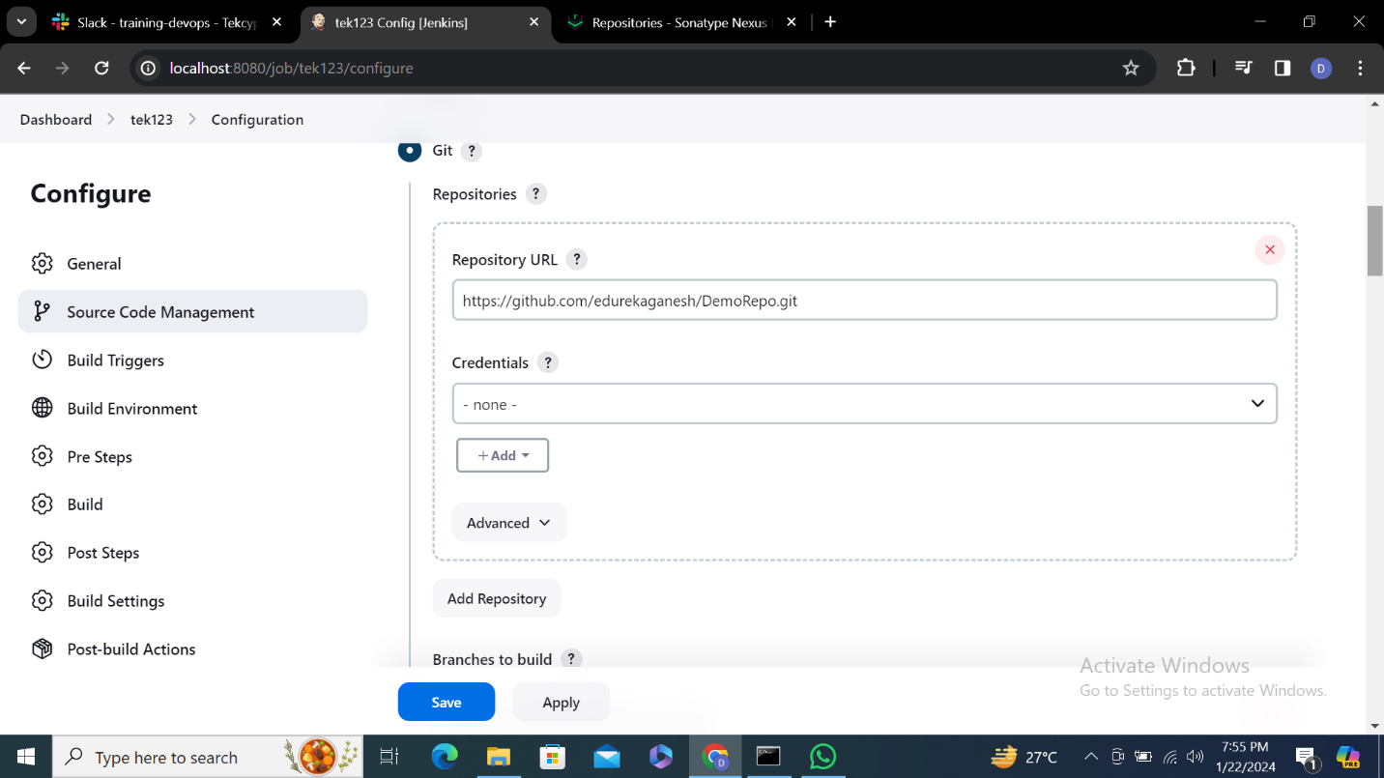

**4.**In goals enter clean compile package

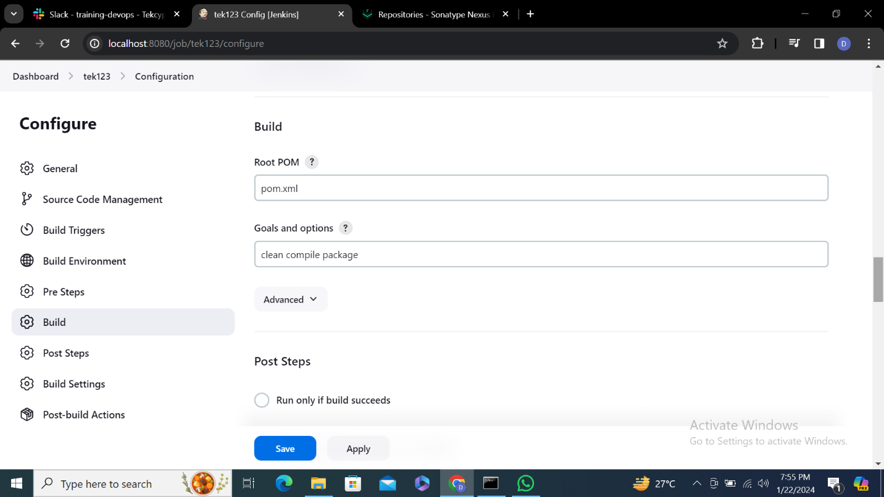

**5.**Select latest version of nexus and enter nexus URL give Jenkins login credentials

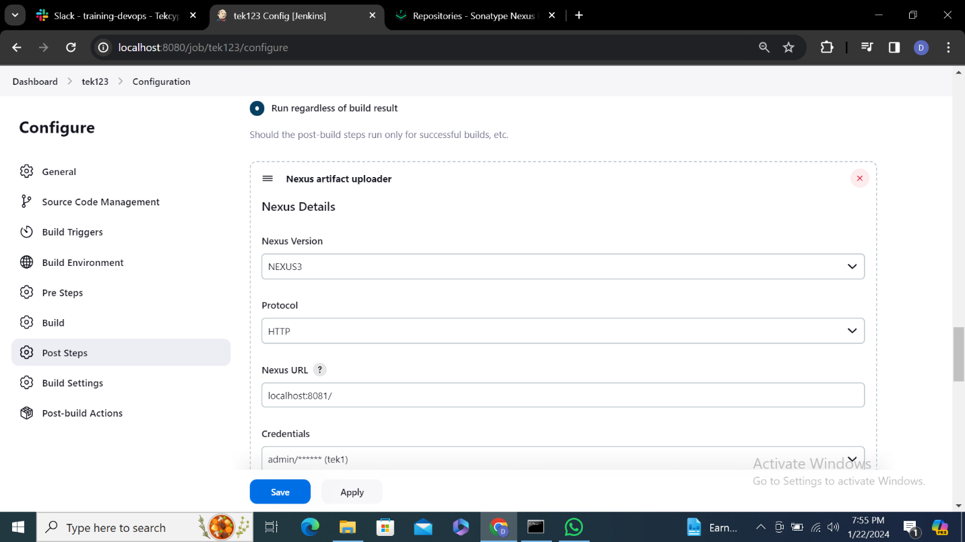

**6.**Create a name in group id where files will stored and give the name what you have created in nexus

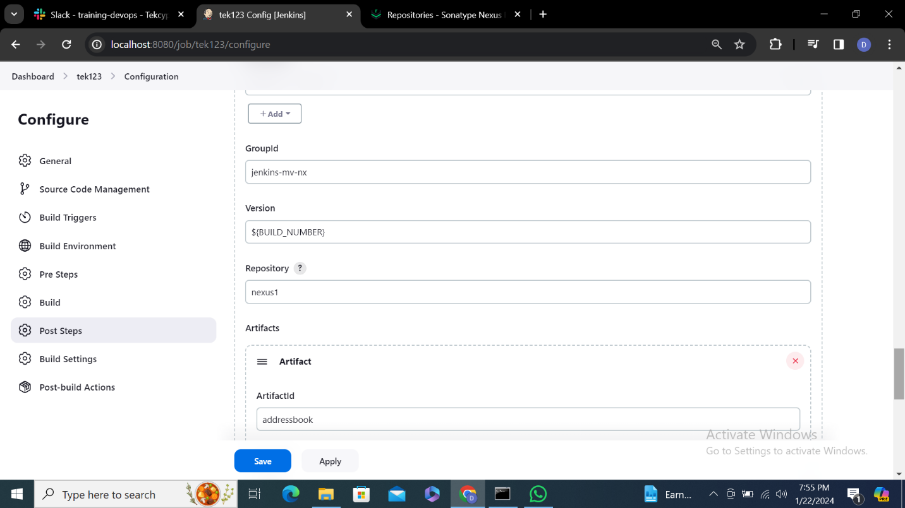

**7.**

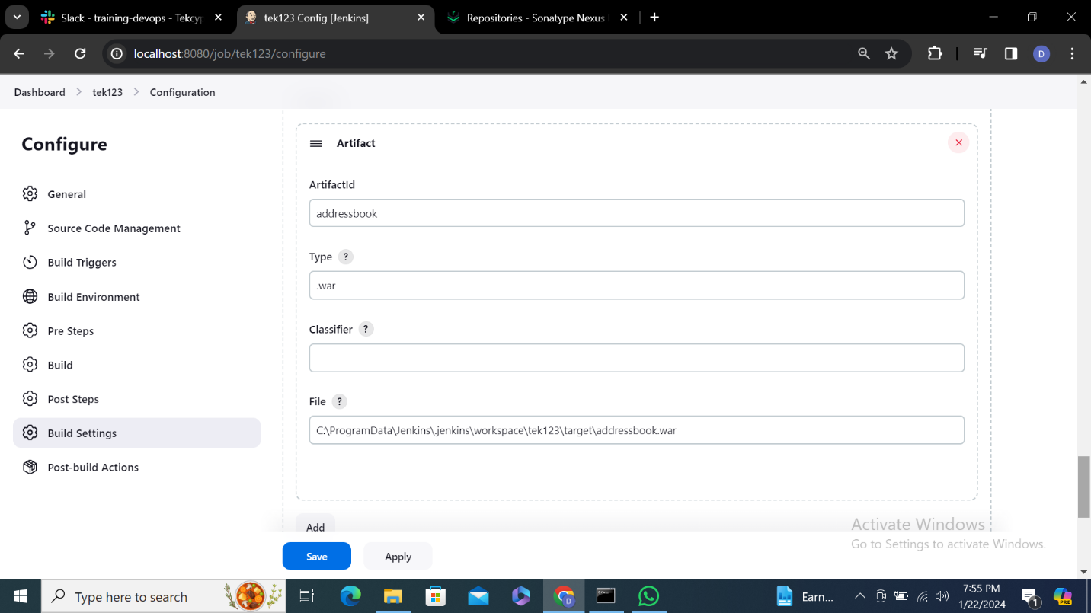

**8.**Click on save

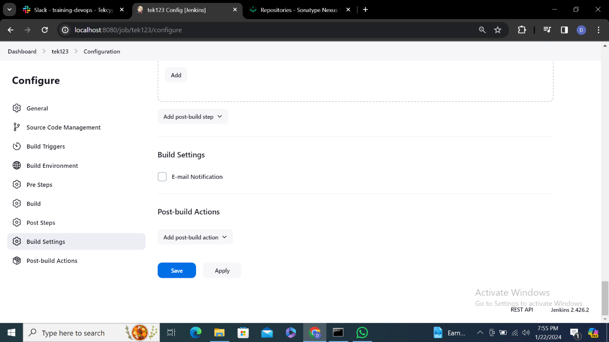

**9.**Enter file name to create repository

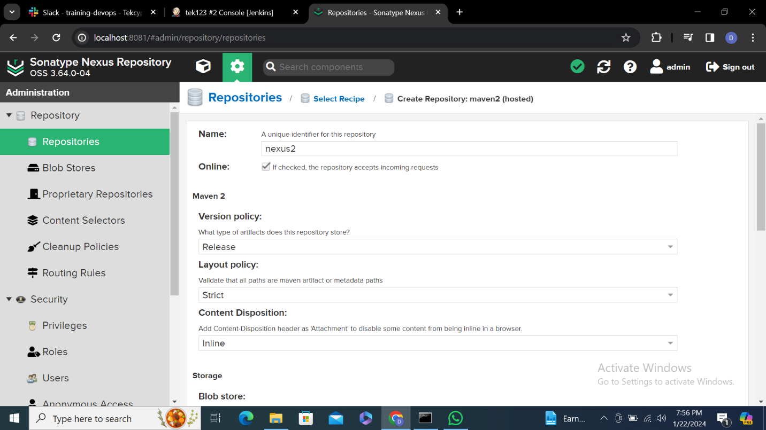

**10.**

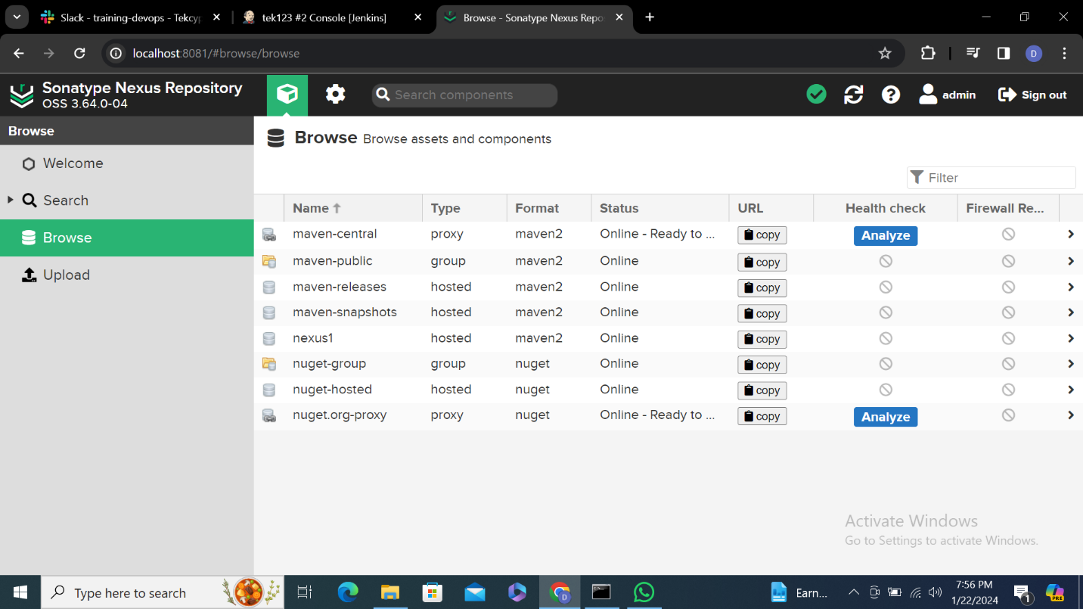

**11.**Click on build now to get result

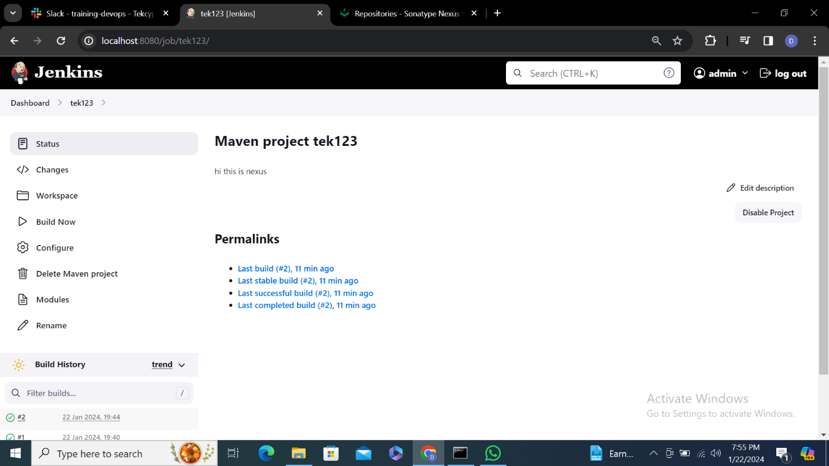

**12.**

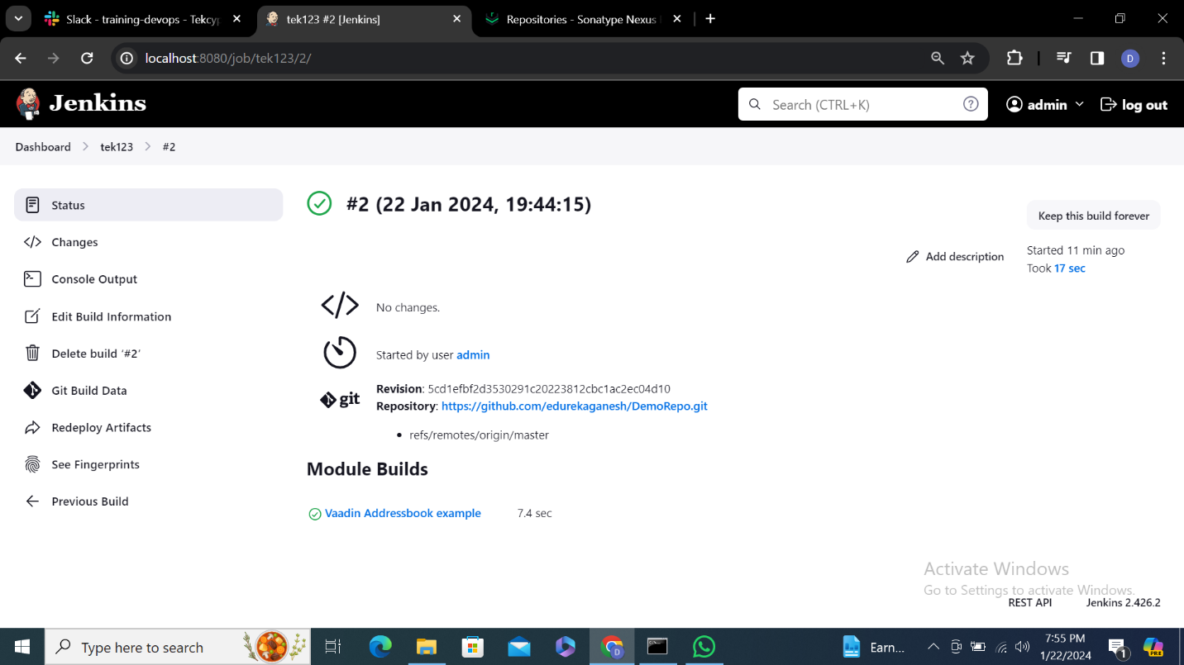

**13.**

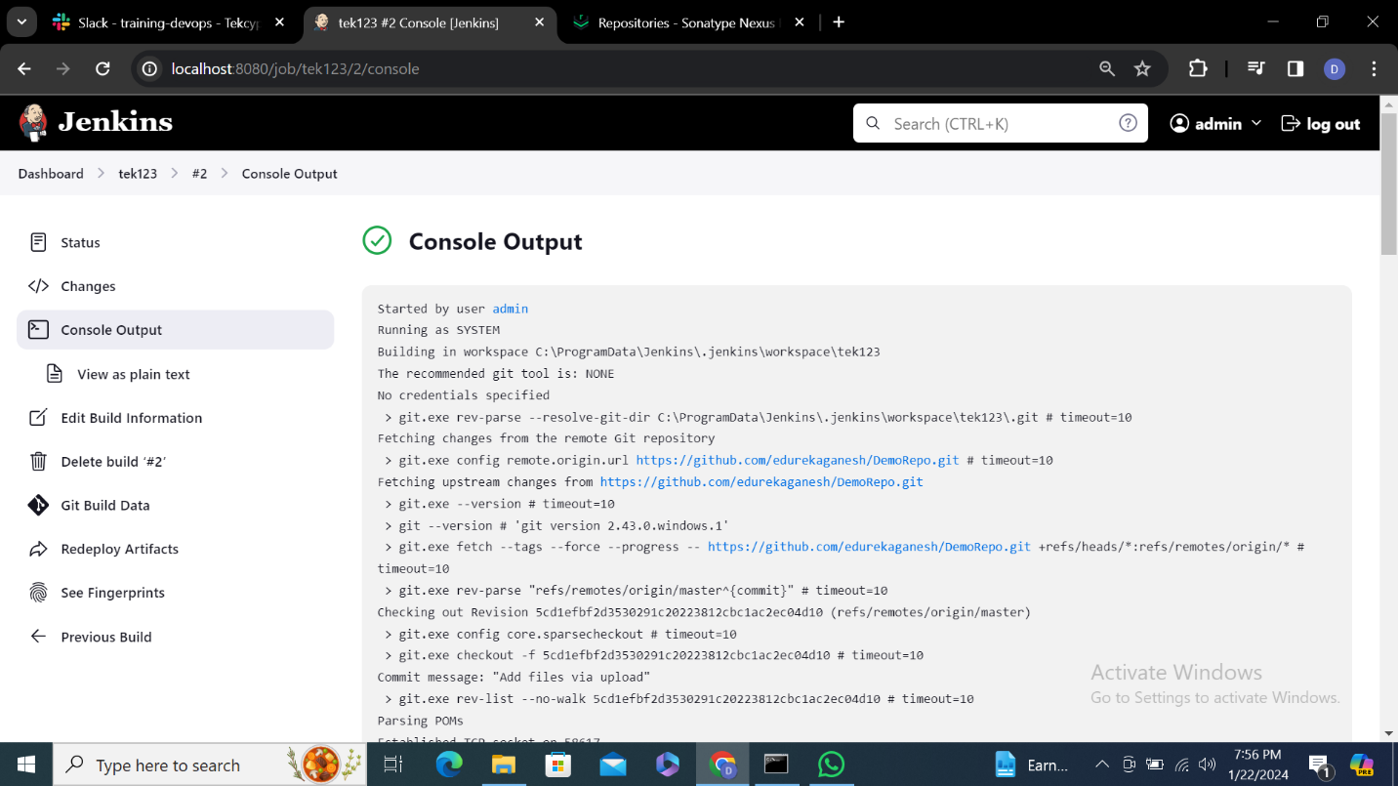

**14.**

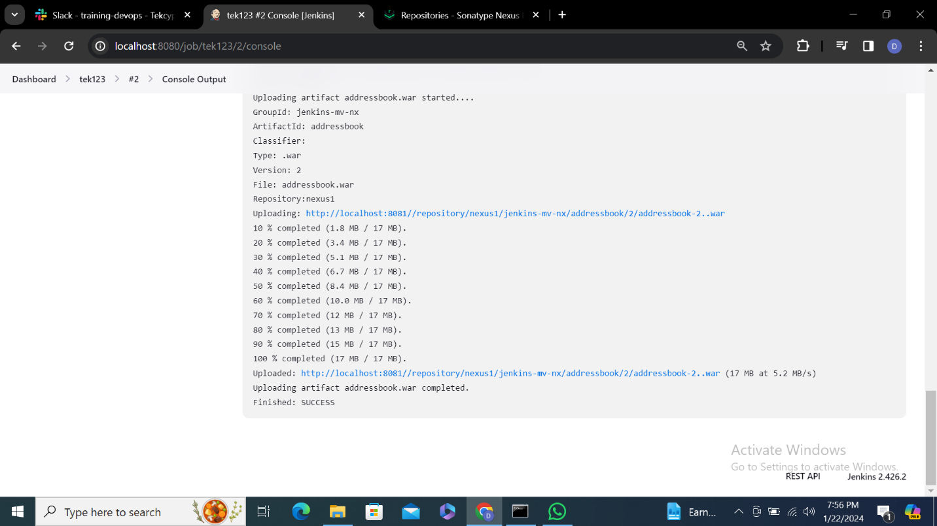

**15.**Files are now moved to nexus repository on nexus1 click on it



**16.**Click on address book2..war you can see file

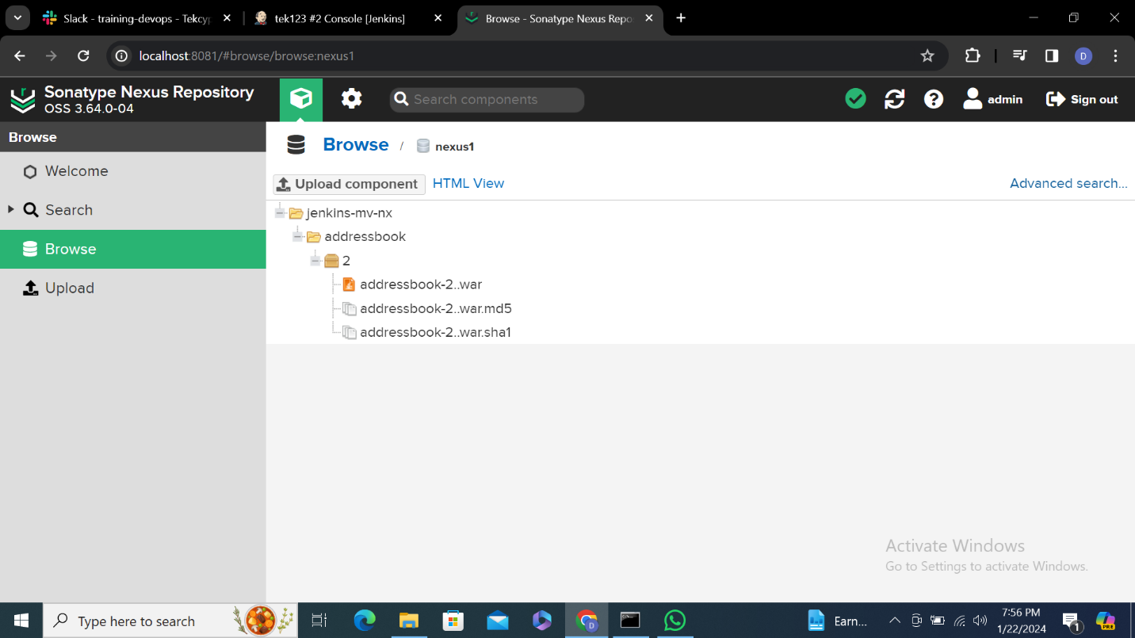

**17.**

